Blackness Primary School

School Improvement Report
Session 2024-25
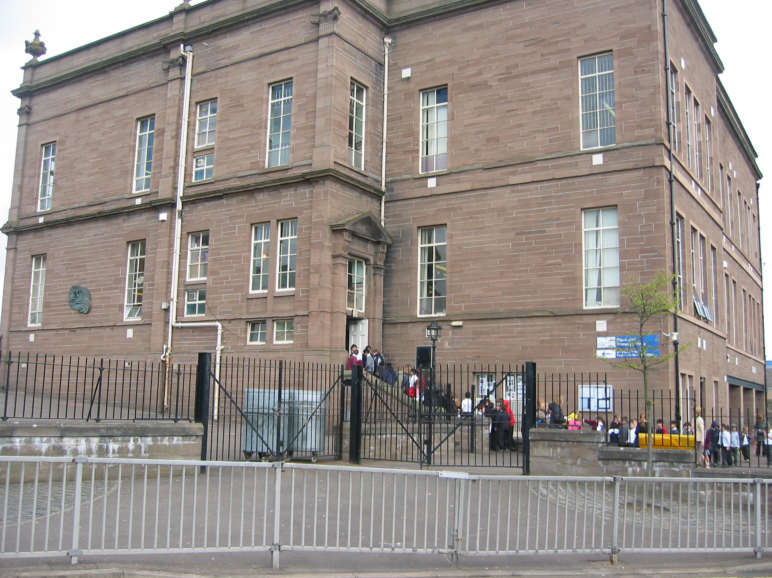

Blackness Primary School
Hawkhill,
Dundee. DD1 5RT
Tel 435939
Email: blacknessprimary@dundeeschools.scot

This document shares and celebrates the improvements in our School and embraces all ages and stages. It is based upon our School Improvement Plan for session 2024-25.
School Aims:
Why are we here?
- Blackness Primary School provides staff, pupils and families with experiences that promote a positive mindset, engagement, learning and enjoyment. This is developed through relationships between home, school and our community whilst drawing on wider expertise and resources. We operate on a level of mutual respect, with the understanding that “Everyone Here Matters”.

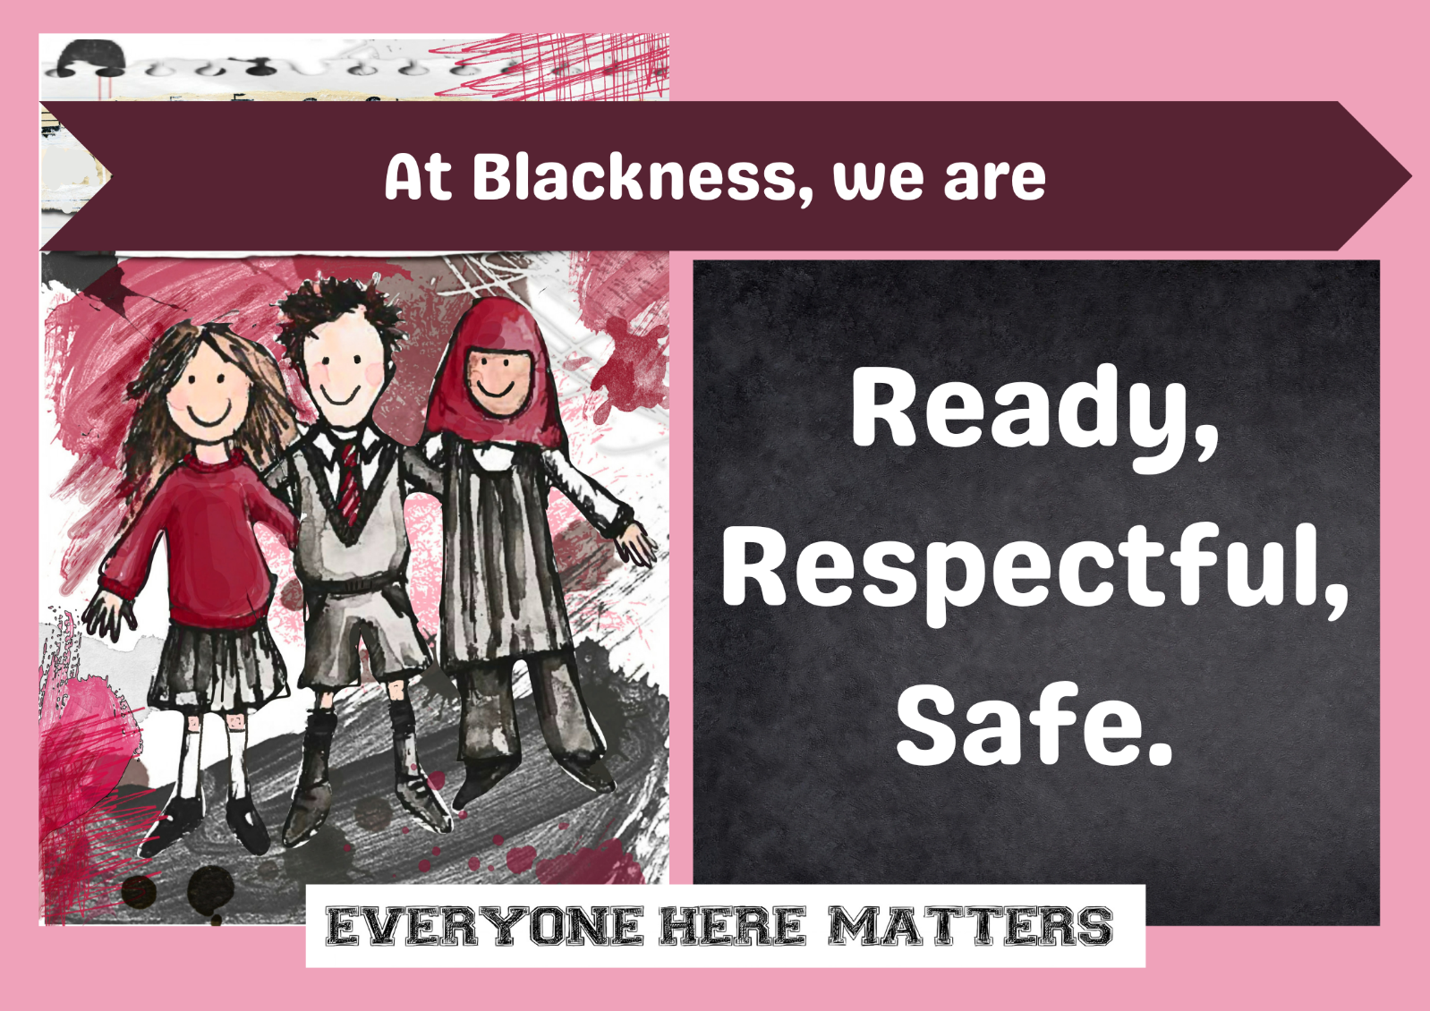

We develop our community through supported challenge and a wide range of opportunities and experiences. We will:

- nurture positive relationships:

- promote and extend learning

- develop engagement in learning:

- include our whole community:

- promote and support health and wellbeing in our community

All staff demonstrate ambition to improve and develop our community’s skills and opportunities. We work together to overcome any challenges we may encounter.

Context of the School:
Blackness Primary School is a non-denominational school which serves the Westend of Dundee. The area comprises a mix of local authority, private and rented accommodation and is culturally diverse. Pupils from the school are mainly in the catchment area for Harris Academy. The school in 2024-25 supported around 345 pupils from a wide range of cultural backgrounds. The school roll regularly changes due to the fluctuating nature of our school population, many of whom are from out with Scotland. The school was arranged into 13 classes with three composite classes. There was an allocation of 17.2 teachers, including a Principal Teacher, a Depute Head Teacher and Head Teacher. Free school meal entitlement was 14% of the pupil population and 5% of our pupils lived in SIMD1 and 2. 31% of our pupils are bilingual with 35 home languages spoken in addition to English.

We receive Pupil Equity Funding of £51,450 to support our work in providing the best possible opportunities for our learners, particularly those who are at risk of missing out due to financial circumstances. Some of this was used to enhance our staffing levels, including an additional 0.5 LCA and an Active Schools Assistant. Our Cost of the School Day action plan outlines our commitment to removing financial barriers and promoting an inclusive environment with equal opportunities for all. This is supported by our School and Family Development Worker who works closely with families in our school.

Almost all pupils come to school ready to learn and we enjoy very strong support from all stakeholders in our local community especially from parents and partners.

We have introduced a House system in Blackness this session and this is already showing positive impact on the life of the school. This has allowed the children to develop relationships across the school community including other children and adults. House Activity Afternoons and House Lunches took place and will be reviewed to allow plans for next session. Pupil Leadership has been a key part of this and included P7s and P6s being appointed as House and Vice Captains. They have then led activities and helped supervise lunches.

The priorities for the year’s improvement plan were determined by our on-going self-evaluation of the life and work of our school, including a local authority Collaborative Improvement Visit in January 2025. As a result of this visit, we have realigned our improvement priorities and our focus for the second half of the session has been related to developing our approaches to inclusive practice in line with DCC strategy.

Attainment Data 2024-25
(percentages)
 | Reading | Writing | Talking and Listening | Numeracy
Primary 1  (CFE Early Level) | 88 | 86 | 88 | 86
Primary 2 | 95 | 88 | 93 | 93
Primary 3 | 98 | 90 | 98 | 90
Primary 4  (CFE 1st Level) | 90 | 86 | 90 | 90
Primary 5 | 90 | 87 | 93 | 93
Primary 6 | 94 | 89 | 94 | 97
Primary 7  (CFE 2nd Level) | 91 | 91 | 91 | 87

Continuous Professional Learning:
Over the past year, our staff members have undertaken a wide range of training and development activities to support their continued personal professional learning and the priorities within our school improvement plan. These have included the following:

- We have continued to focus on the development of learning and teaching approaches. All teaching staff undertook professional learning related to promoting pupil engagement and participation in learning. This was delivered by Dundee City Council (DCC) Pedagogy Team.

- All our teachers have visited other schools to observe colleagues’ delivery of learning and teaching in their setting. Subsequent reflections undertaken and these have informed improvements to their own practice.

- Our teaching staff undertook professional learning related to developing out approaches to assessment within listening and talking. This involved sharing practice around assessment and agreeing standards of progress. This was delivered by DCC Pedagogy Team.

- All staff were involved in a CLPL session that focussed on The Dundee Standard for Inclusive Practice and reflected on what is inclusive practice through professional reading and discussion. This was delivered by Denise Martin from Dundee Educational Psychology Service (DEPS).

- All teachers have visited other school settings to view and consider the learning environment and how we can learn from this to improve our learning environment at Blackness.

- All teachers have engaged in training in the use of a Health and Wellbeing Tool that supports understanding of pupil wellbeing. This was delivered by DCC Health and Wellbeing Officer.

- All staff have completed a UNCRC e-learning module.

- Moderation has taken place within school and within our cluster and this has focussed on developing shared understanding of expectations in teacher judgement of children’s progress. We have also engaged the DCC Pedagogy Team in this process with our P1, P4 and P7 teachers discussing and verifying attainment predictions. It was found that these were accurate.

- Learning to Read development days supported our commitment to continuing to improve our learning to read programme. These days included modelled lessons, group discussions and a focus on our data, using this to plan next steps for interventions or targeted support.

- Training in the use of shared, consistent language through use of scripts when supporting pupils who have additional support needs was delivered to all staff by Longhaugh Support Group Staff.

- Our P1 teachers have engaged in professional learning linked to play pedagogy. They have attended training, engaged in professional reading and visited other settings to support the development of approaches in Primary 1. This included a sharing practice event with our cluster schools. They also delivered an input to raise awareness of their learning with our teaching and support staff.

Our support staff have also been involved in training related to our school improvement priorities. This has included:
- Sensory Processing Training – delivered by Occupational Therapists
- Total Communication – delivered by Speech and Language Therapists
- Transitional supports – delivered by the Accessibility and Inclusion Service
- Emotional Regulation – delivered by LSG
- Autistic Play – delivered by AIS

Members of staff have also undertaken a variety of leadership roles related to our school improvement priorities eg Digital Leaders, Reading Leaders, leading working groups linked to school improvement priorities and resource organisation.

Individual teachers have been involved in a range of personal CLPL that was identified at their annual Quality conversation. This has included areas such as filmmaking, play pedagogy, use of IT, dyslexia training courses.
Teachers have also represented Blackness through attendance at citywide groups tasked with developing areas of practice e.g. Reading Leader Meetings, Numeracy Champion Meetings, Cluster Support for Learning Meetings, PEPAS meetings and QAMSO meetings.

Review of Improvement Progress for Session 2024-25
School Improvement Priority 1
Improving our approaches to inclusive practice, including the learning environment, resources and a range of pedagogy resulting in effective learning opportunities for all.

Progress and Impact:

Learning, Teaching and Assessment:
All teaching staff attended three CLPL sessions delivered by Kerri Tough of DCC Pedagogy Team. These sessions focussed on developing a shared understanding of how lesson design and planning can promote pupil participation and engagement in learning. This included an opportunity for teachers to share practice and to identify areas to develop within the planed learning and teaching experiences of our pupils.

Discussions and sharing of learning during these sessions have promoted increased awareness of the importance of pupil voice and leadership within lessons, alongside providing teachers with a range of strategies to use in lessons. Teacher evaluations indicate that they feel increased confidence in ways to promote pupil engagement in learning.

All teachers have visited another classroom out-with Blackness to view learning and teaching in action. They engaged readily in collaboration with colleagues out-with our school and benefited from the sharing of practice. Teacher reflections highlighted areas of practice that they would bring back to their own setting.

Our staff team have been introduced to The Dundee Standard of Inclusive Practice. An introduction and awareness raising session was led by Denise Marting (DEPS). We explored the online site and resources to acquire further knowledge and understanding of inclusive approaches. Subsequent evaluations highlight that this resource is a helpful tool and ways that we can use this to support our work in developing our approaches to inclusive practice in line with DCC strategy have been identified.

This has led to all staff being aware of policy and approaches being taken forward within DCC and has allowed them to consider their role within this. Further sessions are planned to continue this and lead to a shared understanding of inclusive practice.

We have continued to engage in moderation of teacher judgement related to pupil progress within Curriculum for Excellence. Engagement with DCC Pedagogy team has supported this process and led to confirmation of teacher judgements.

Learning Environment:
Throughout this session our school staff have worked to adapt and reorganise the learning spaces within our school. This has included the purchase of resources to create a de-escalation space and to add to our nurture provision. In doing so we have been better placed to support those children who require additional support.
We have introduced the use of visuals to support communication around the school and when communicating information and instructions to pupils. All staff have a set of visuals, fix it folders, calm kits and all classrooms have visual timetables and visuals to support expected behaviours. This has helped us to begin to use these more consistently. Further engagement in developing this will be supported by DEPS and SALTh.
We have engaged with staff from Longhaugh Support Group to develop our knowledge and understanding of using scripted language to support a structured approach to using language when communicating with children. All staff attended an information session, and we have displayed scripts in classrooms and learning areas. These approaches link with previous training in our understanding of Trauma Principles and will be developed further next session.
All teachers carried out an environmental audit to review the learning environment within their classroom. They identified areas that were a strength and set next steps to improve the learning environment. This has led to adaptations made at classroom level. Teachers have all had the opportunity to visit other settings to gain insights into a variety of learning environments and to reflect on any areas that would enhance the provision at Blackness.
Using information gathered from professional reading and referring to the Dundee Standard of Inclusive Practice we have created a Blackness Learning Environment Policy, and this is aimed at creating clear guidance and thus consistency of approaches at a universal level that benefits all pupils. This has been shared and discussed with all staff and will be used to further develop our learning environment next session, involving pupils and parents.

NEXT STEPS

To continue to develop a shared understanding of inclusive practice at universal level through further engagement with the Dundee Standard of Inclusive Practice.

Review our Learning and Teaching policy and relaunch this in line with our work on inclusive practice, linking to The Dundee Standard of Inclusive Practice.

To further develop the delivery of learning and teaching pedagogy to ensure consistent high-quality experiences for all learners in line with our revised Learning and Teaching Standard and HGIOS.

To continue to develop the consistency in learning environments within classrooms and spaces across our school to ensure that these support inclusive practice and quality universal provision.

Further development of using visuals and scripting to support communication.

Increase emotional literacy through the language of zones of regulation.

School Improvement Priority 2:
Develop our approaches to planning for assessment, gathering assessment evidence and recording assessment information to ensure this is integral to our planning of learning and teaching.

Progress and Impact:

During this session we have continued to engage in moderation activities involving discussions around learner progress. Teachers have been supported by DCC Pedagogy Team in moderating within writing and they validated teacher judgements.

All teaching staff were involved in professional learning related to our approaches to assessing Listening and Talking. These sessions were delivered by DCC Pedagogy Team and enabled us to explore ways in which we can capture learner progress and enable pupils to demonstrate achievements related to the progression pathways. Teachers shared a range of assessment evidence and discussed progress made in relation to this. This collaboration has led to an increased awareness of how assessment can be planned in Listening and Talking.

We continued to make use of our cohort tracking sheets introduced last session. These enabled us to record and track progress of all pupils within Literacy, Numeracy and Health and Wellbeing.

Our supporting learner’s teacher has introduced the use of milestones planners and precision teaching with set targets that are regularly reviewed and adapted. This has supported the planned learning for those with identified additional support needs and allowed for tracking of progress for these pupils.

Next Steps:

Continue to develop role of QAMSO in supporting moderation activities, working alongside cluster and SIP schools.

Introduce the new DCC Tracking and reporting tool next session. This will include raising awareness sessions and in-house training delivered by identified superusers who will receive full training.

School Improvement Priority 3:

Develop our approaches to planning, teaching and assessing numeracy with a focus on conceptual understanding.

Progress and Impact:

Our Numeracy Working Group audited core and additional resources available for teaching Numeracy. They created a guide for teachers to refer to.

They identified additional resources required to support effective learning and teaching within Numeracy, including the use of Conceptual Understanding in Number approaches. Some of these have been purchased, including Talk for Maths that is enhancing the development of the language of Numeracy in Primary 1 to 3.

When planning for Numeracy learning we continue to make use of DCC Progression Pathways, and we use a range of resources to deliver the identified outcomes within each pathway.

We have reviewed assessment material and identified more appropriate assessments to use when assessing children’s progress within Numeracy.

Teachers have continued to include CuiN approaches within numeracy lessons with concrete materials and visuals used regularly in these. These were seen during classroom observations that focused on the area of Numeracy learning and followed a range of CLPL from last session.

Our Numeracy Working Group has created a Numeracy Policy that informs our pedagogy and approaches to teaching Numeracy. This was done in conjunction with DCC Pedagogy Team and is based on current research. The policy has been shared with teaching staff and will be used to support consistency in our approaches to delivering Numeracy in our classrooms across the school.

Next Steps:

Continue to develop our use of CUIN through sharing of practice and revisiting professional learning undertaken in this area.

To develop the use of our Numeracy Policy to inform planning, teaching and assessment in Numeracy.

Improvement Priorities for Session 2025-26

- SIP PRIORITY 1

Increase our understanding of inclusive practice at universal level, including how we organise the classroom learning environment.

- SIP PRIORITY 2

Further develop a range of pedagogies with the intention of increasing engagement in learning for all pupils.

- SIP PRIORITY 3

Improve attendance, engagement and thus attainment of an identified group of pupils.

Please visit www.careinspectorate.com or https://education.gov.scot/what-we-do/inspection-and-review/reports for Care Inspectorate or HMIE Inspection Reports.
https://parentzone.org.uk/
Further Information can be found at:

BLACKNESS PRIMARY SCHOOL WEBSITE

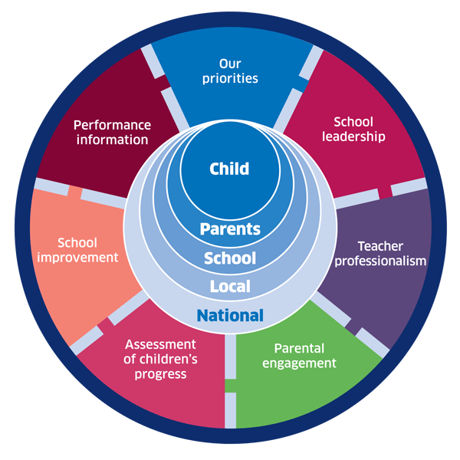 | 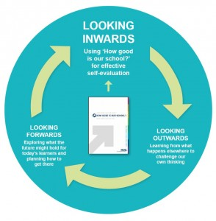 |  |   Dundee Education Plan  https://www.dundeecity.gov.uk/sites/default/files/publications/annual_education_plan_2017-18.pdf
National Improvement Framework  http://www.gov.scot/Publications/2016/01/8314 | HGIOS 4 Self-evaluation https://education.gov.scot/improvement/Documents/Frameworks_SelfEvaluation/FRWK2_NIHeditHGIOS/FRWK2_HGIOS4.pdf | Tayside Plan C&FS  External Link ' Tayside_Plan 1a.pdf'

Closing the attainment gap between the most and least deprived children

Using the six point scale from HGIOS to evaluate 1.3 2.3 3.1 3.2
Evaluative comment on attendance and exclusion data

Schools should evaluate their work relating to the Scottish Attainment Challenge, and the impact of the Pupil Equity Fund on relevant children

Parents other stakeholders – evaluate effectiveness

Schools may also wish to add further credibility to their reports through independent validation, endorsement or confidence statements, for example based on:
• an inspection from HMI;
• an independent validated self-evaluation; and/or
• specific endorsements/confidence statements from pupil councils, parent councils or local community groups such as employer or partner groups.

